**Practical No. 07**

**Aim: Running location service in Docker.**

(Create docker hub login first to use it in play with docker)

Now login in to Play-With-Docker

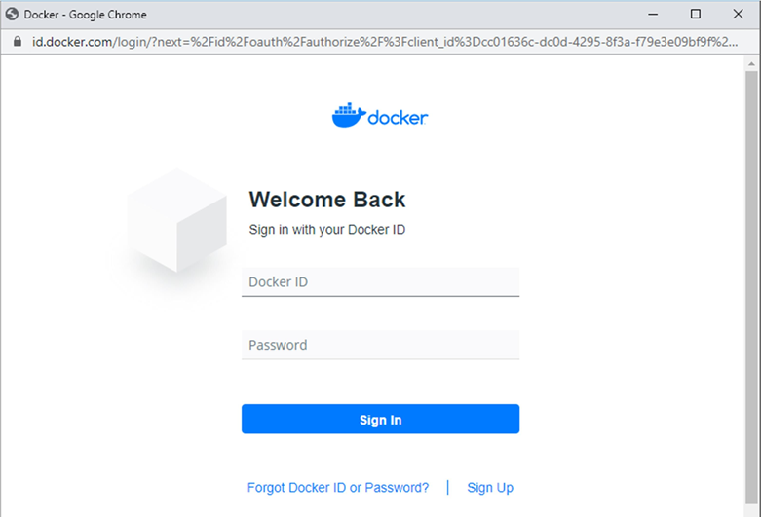

Click on Start.

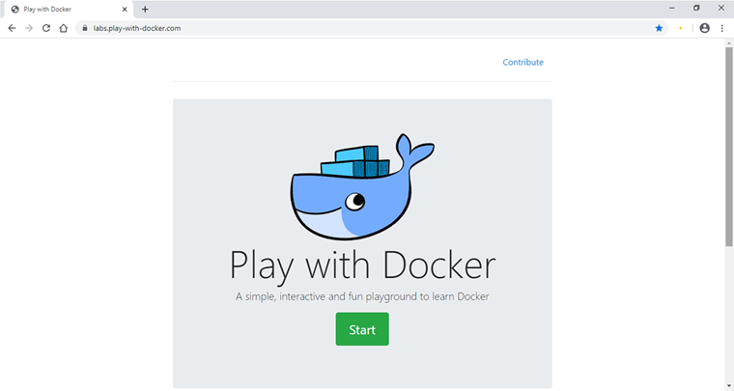

Click on Add New Instance.

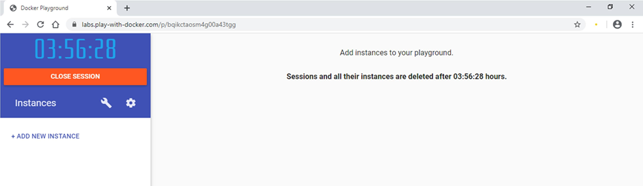

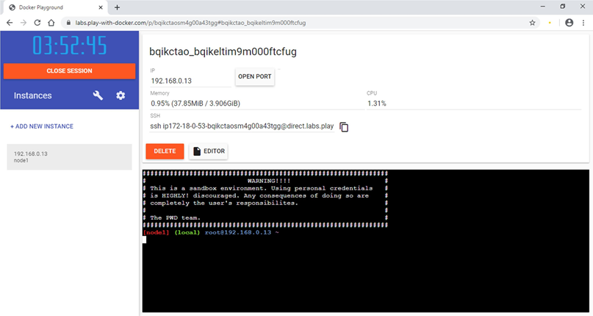

Start typing following commands

Command: To run teamservice

docker run -d -p 5000:5000 -e PORT=5000 \

-e LOCATION__URL=http://localhost:5001 \

dotnetcoreservices/teamservice:location

**Output:** (You can observe that it has started port 5000 on top)

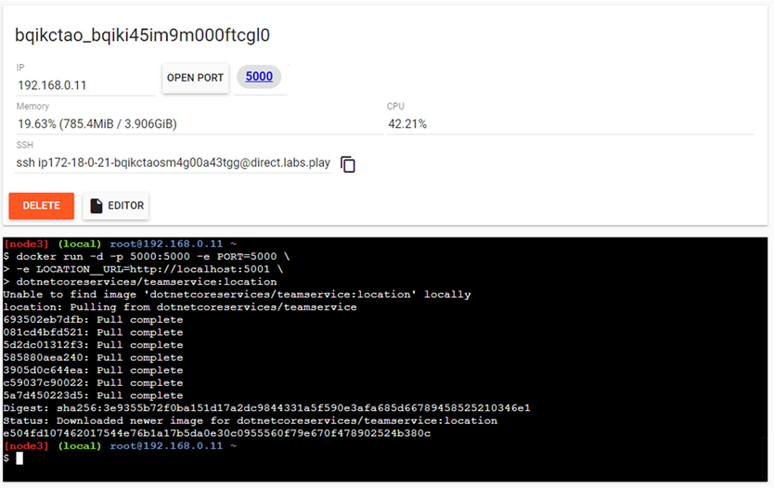

Command: to run location service

docker run -d -p 5001:5001 -e PORT=5001 \

dotnetcoreservices/locationservice:nodb

**Output:** (Now it has started one more port that is 5001 for location service)

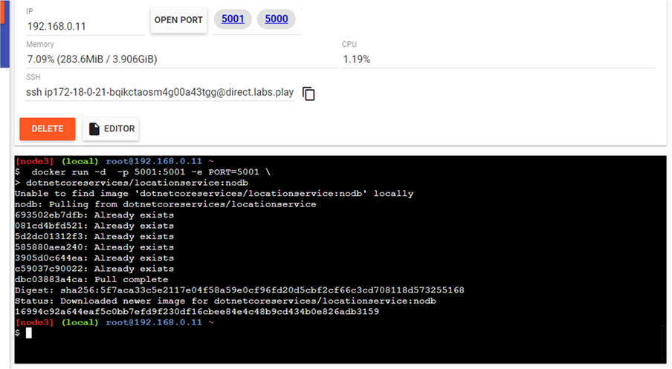

Command : to check running images in docker

docker images

**Output:**

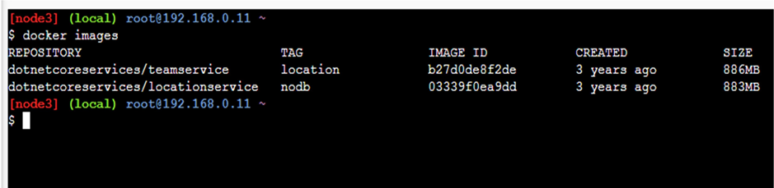

Command: to create new team

curl -H "Content-Type:application/json" -X POST -d \

'{"id":"e52baa63-d511-417e-9e54-7aab04286281", "name":"KC"}' http://localhost:5000/teams

**Output:**

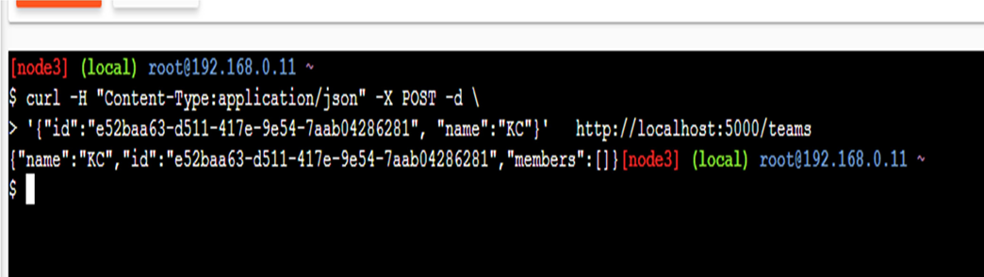

Command: To confirm that team is added

curl http://localhost:5000/teams/e52baa63-d511-417e-9e54-7aab04286281

**Output:**

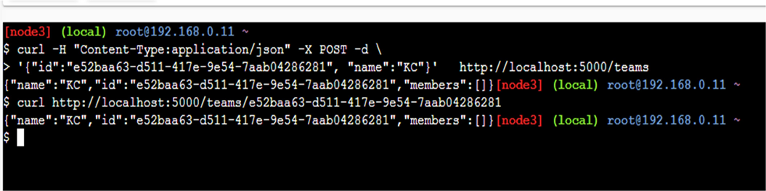

Command : to add new member to team

curl -H "Content-Type:application/json" -X POST -d \

'{"id":"63e7acf8-8fae-42ce-9349-3c8593ac8292", "firstName":"Monte", "lastName":"Carlo"}' http://localhost:5000/teams/e52baa63-d511-417e-9e54-7aab04286281/members

**Output:**

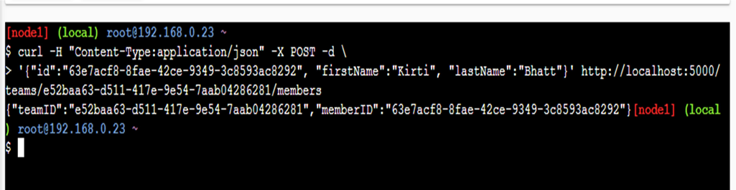

Command: To confirm member added

curl http://localhost:5000/teams/e52baa63-d511-417e-9e54-7aab04286281

**Output:**

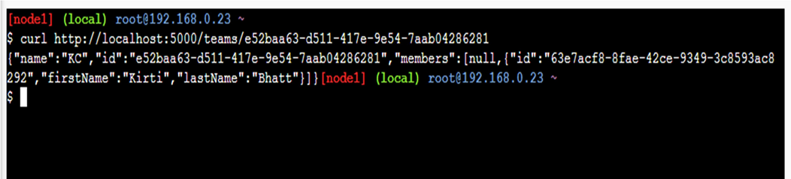

Command: To add location for member

curl -H "Content-Type:application/json" -X POST -d \

'{"id":"64c3e69f-1580-4b2f-a9ff-2c5f3b8f0e1f", "latitude":12.0,"longitude":12.0,"altitude":10.0, "timestamp":0,"memberId":"63e7acf8-8fae-42ce-9349-3c8593ac8292"}' [http://localhost:5001/locations/63e7acf8- 8fae-42ce-9349-3c8593ac8292](http://localhost:5001/locations/63e7acf8-%208fae-42ce-9349-3c8593ac8292)

**Output:**

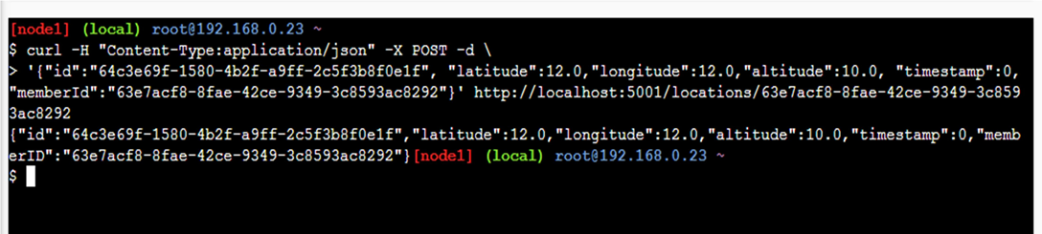

Command: To confirm location is added in member

curl http://localhost:5001/locations/63e7acf8-8fae-42ce-9349-3c8593ac8292

**Output:**

